Visual Verifier

Professor Smoak

Final Report

Team:
Laith Fakhruldin
Nahid Ahmed
Spencer Martinez

11/06/2023

List of Figures
Figure 1 Informs the robot to locate object 1 and proceed drawing square, if found. Otherwise, search for Object 2 9
Figure 2 Informs the robot to locate Object 2 and proceed to drawing a triangle. Otherwise, search for Object 3 9
Figure 3 Informs the robot to search for 2D house and draw checkmark. Otherwise, draw 'X' 10
Figure 4 Shows instructions for drawing a checkmark if complete or 'X' if object house is not complete 10

Table of Contents
List of Figures 2
Problem Description 4
Literature Review 5
Machine Vision in Robotics 5
Robots and AI Pioneering in Shaping Our Future 7
Program Planning 8
Future Work and Recommendations 11
Conclusions 12
References 13

Problem Description
Today, many of our current jobs can be automated without the use of human interaction and can be more efficient from a time and cost perspective. As technology continues to develop and improve, we can greatly eliminate the margin of error in certain industries and reduce the time required to perform tasks, especially for employees who only need to view a particular product and ensure it is built correctly. This is seemingly true for the manufacturing and automotive fields where patterns may need to be detected to ensure accuracy of the parts being created.
For our project, our team decided to create a teach pedant program that will take advantage of the vision capabilities and precise movements that the iRVision LR Mate 200iD4S has to offer. Specifically, our team is going to be using object detection/recognition and precise linear movements to create a two-dimensional house. This will be created by using three objects that are placed within the camera’s field of view. If only one object is within the camera’s view, for example, it may only draw a square, serving as the outside of the house. If object two is the only object detected, it may only draw a triangle, which would serve as the roof, and the same continues for the third object (which would serve as the door). By placing multiple objects within a specified area, we can draw a two-dimensional house that can be taught to the robot which then checks to see if the house was successfully drawn. If the correct picture is drawn, a checkmark will be created beneath the picture, indicating that the correct picture is drawn. If the picture isn’t deemed to be a house, a ‘X’ will be drawn beneath the picture created. The capability of this robot allows for unique, creative design ideas that can be deployed at an organizational level.
When it comes to deploying our product at the consumer level, our team has ensured that objects are successfully taught and thoroughly crafted. Our project involves numerous stages such as testing, software development, and more. By carefully revisiting each of these areas, even if the current stage varies greatly from the previous one, we can continuously improve our project by taking the required actions based on our new findings.

Literature Review

Machine Vision in Robotics
Machine vision plays a pivotal role in robotics and automation, offering several indispensable advantages for diverse industries, including precision, speed, error reduction, safety enhancement, improved quality control, cost savings, and seamless integration with robotic systems (Yasar & Lutkevich, 2023). Incorporating machine vision into industrial robotics enhances product quality control by analyzing specific characteristics of components produced on the assembly line to determine their compliance with quality standards. This level of precision surpasses human capabilities, ensuring consistent and accurate inspections, even in high-speed production environments.
One of the most significant benefits of machine vision lies in its exceptional precision and consistency in tasks that demand visual inspection and analysis. Unlike humans, machine vision systems do not suffer from fatigue, thereby guaranteeing consistently accurate inspections, which are critical for upholding product quality and uniformity. Furthermore, the swiftness and efficiency of machine vision systems are helpful in industries with rapid quality control requirements, such as electronics manufacturing, pharmaceuticals, and food processing. These systems can rapidly inspect hundreds or even thousands of items per minute, significantly strengthening production throughput when tasks are automated.
Machine vision also excels in error reduction compared to human operators, who are prone to costly mistakes that lead to defects and rework. By eliminating the potential for human errors in tasks like optical character recognition, object recognition, and defect detection, machine vision not only saves time but also minimizes material wastage and production downtime. In manufacturing and industrial settings, combining machine vision with robotics enhances workplace safety. Robots equipped with machine vision can undertake tasks that pose risks to human workers, effectively reducing the chances of injuries and exposure to hazardous conditions.
Another crucial aspect of machine vision is its ability to identify even the smallest defects, abnormalities, or inconsistencies in products, a task beyond human visual capabilities. This level of inspection is vital in industries where strict quality control is a must, such as automotive manufacturing, electronics assembly, and pharmaceutical production. Additionally, machine vision systems are highly versatile and adaptable, capable of customization to handle diverse inspection types, from defect detection in manufactured goods to guiding robots through complex environments. Over the long term, machine vision contributes significantly to cost savings for industries and stakeholders, leading to substantial gains in profitability. Automation driven by machine vision reduces labor costs, minimizes defects, and optimizes production processes, ultimately increasing profitability.
In conclusion, machine vision's pivotal role in robotics and automation lies in its ability to deliver precise, consistent, and efficient visual inspection, contributing to enhanced quality control, safety, and cost savings across a wide array of industries. The integration of machine vision with robotics not only boosts the capabilities of automation systems but also unlocks new opportunities for innovative applications.

Robots and AI Pioneering in Shaping Our Future
Robotics and artificial intelligence (AI) are undeniably the future of mankind, offering transformative potential across various areas. These two fields are rapidly evolving, poised to revolutionize the future of humanity by undertaking tasks ranging from the simplest to the most advanced in our daily lives (Helfrich, 2022). They have undergone significant developments, leading to the creation of machines capable of performing tasks with remarkable speed and accuracy. Contrary to concerns of widespread job displacement, robotics and AI are becoming indispensable collaborators, enhancing human capabilities and productivity.
Looking back at the past few decades, we have witnessed an unprecedented surge in the development and practical application of robotics and AI. These technologies have reassured us that their purpose is not to replace human jobs but to work alongside us, expanding our abilities. AI-driven virtual assistants like Alexa, Siri, and Google Assistant have seamlessly integrated into our daily routines, demonstrating the matching coexistence between AI and human interaction. It is essential to understand that while robotics and AI are often used interchangeably, they represent distinct yet interconnected fields (Helfrich, 2022). Robotics primarily involves the design and programming of machines to execute tasks autonomously, reducing the need for human intervention. In contrast, AI encompasses systems that replicate human cognitive processes, enabling machines to learn, solve problems, and make decisions independently, without relying solely on pre-programmed instructions.
Robots and AI collaborate to build a brighter future for human society, excelling in areas such as enhancing the quality of life, addressing global challenges, automating tasks, and safeguarding the environment, where humanity has room for improvement. These technologies possess the potential to enhance various features of our lives, from education to household chores. Humanoid robots facilitate personalized learning, while cloud-connected robots can adeptly manage everyday tasks like vacuuming and cooking. Moreover, Robotics and AI offer promising solutions to some of the world's most pressing global challenges, including climate change, energy security, and complex healthcare issues. What’s more, they contribute to task automation by handling repetitive and routine tasks, freeing up valuable time and energy for more creative pursuits within human society. Furthermore, these technologies play a pivotal role in environmental protection by empowering us to better comprehend and safeguard our ecological environment, thereby aiding in the preservation of our natural surroundings. The revolutionary capabilities of robotics and AI are undeniable. These technologies are poised to shape our future in profound ways, offering solutions to complex challenges and significantly improving our quality of life.

Program Planning
When planning out a project of this caliber, our team discussed what functionality was available in the teach pendant and questioned how the process was going to be executed. First, we immediately understood that we needed to have a point defined that would capture the three objects that were placed within the camera’s field of view, so this was our starting point. This point was referenced numerous times throughout the program to check for each object at different instances. Second, we used the iRVision software to teach our robot the three different objects that were going to be used by using the training mask and emphasis area and ensured that each object had a unique name for the profile that was created. By doing this, we can easily reference our program when implementing our code lines on the teach pendant.
Proceeding with the program planning, we executed the “VISION GET_PASSFAIL” command which would allow us to determine whether the object was successfully detected or if there was an error when attempting to do this. By placing two “IF” statements beneath this line, we can account for when the object is detected or when it is not seen at all. When the object is detected, we allowed our robot to create the shape/drawing that was associated with that particular object; otherwise, it would immediately search for the next object. This process was repeated four times (three objects and final drawing), except the shape being drawn and number of points differs. This was able to be accomplished by using various labels which were placed throughout our program to jump to different lines of code accordingly.
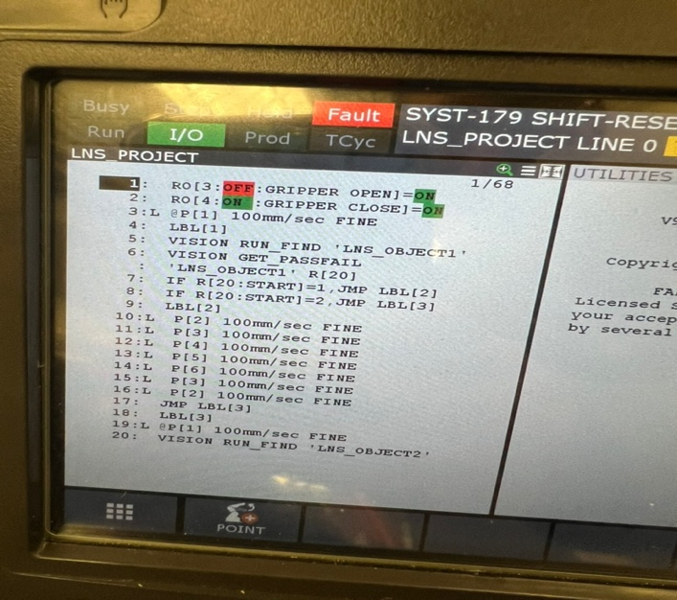
Let’s look at this program more in-depth and see how these events are occurring from the teach pedant. When viewing figure 1, we started by allowing the robot’s gripper to open and close, so that we could allow a marker to be inserted when beginning the program. With the first point that is defined, we were able to allow the robot to search for items in a specific section of our workspace. This point is referenced throughout the entire program, so that we can view the objects available at different intervals. Afterward, the robot will search for the first object and if it is able to be identified, it will draw the base of the house (square). Otherwise, it will search for the second object and draw another portion of the house.
Figure 1: Informs the robot to locate object 1 and proceed drawing square, if found. Otherwise, search for Object 2
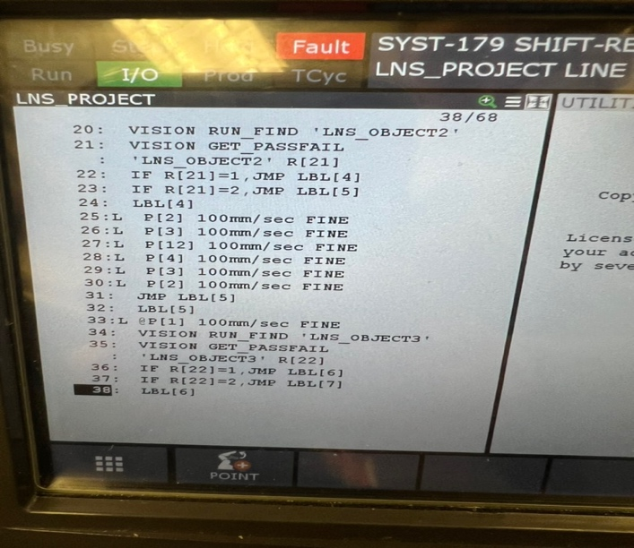
Proceeding with the figure 2, our robot will check the items available in the workspace and search for object 2. If the object is identified, it will begin drawing the triangle for the house using the 6 points that are defined below the fourth label. Otherwise, the robot will return to where the objects are located and see if it can identify the third object and repeat this process. Our team also wanted to note that for each vision program/profile that is specified, such as “LNS_OBJECT1”, there is one object that is taught in each program, which is why we incorporated different programs inside of this singular project. This was done by using the iRVision software and within it, we could specify objects by using the training mask and emphasis area. We were also able to define a score threshold that allowed the program to determine whether an object was identified or not.
Figure 2: Informs the robot to locate Object 2 and proceed to drawing a triangle. Otherwise, search for Object 3
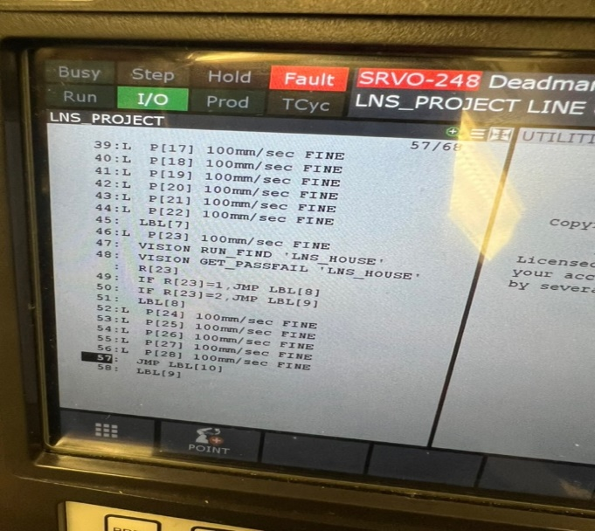
Following figure 3, the program will search for the house that was drawn, and if it has the exterior, the roof, and the door, the house would be marked as identified and a checkmark will be drawn. If all three portions are not shown, an ‘X’ will be drawn to indicate that a house is not present is not completed version.
Figure 3: Informs the robot to search for 2D house and draw checkmark. Otherwise, draw 'X'

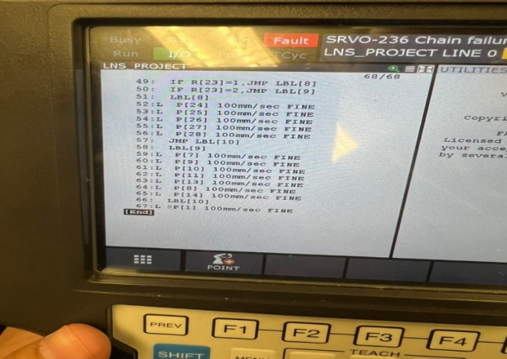
The instructions for drawing the checkmark and ‘X’ are shown in figure 4 which concludes our project. When viewing our results, our team made sure to include a video which demonstrates our finds when all three objects are identified (Martinez, 2023). Additionally, we made sure to show the result when only one object is found (Martinez, 2023).
Figure 4: Shows instructions for drawing a checkmark if complete or 'X' if object house is not complete

Future Work and Recommendations
When it comes to additions that our team would have added to our project, we would have expanded on the amount of objects that were taught to the robot along with the its ability to recognize objects at different angles (opposed to only face down), so that we could identify the full object in three dimensions. Even though our product allows us to recognize a picture of a two-dimensional house, for example, it is important to recognize that when working in a full-production environment, these pictures or objects that are being identified are incredibly detailed and require high amounts of precision, especially when you are verifying an object that is three-dimensional.
Additionally, when creating an improved version of this product in the future, we wish to optimize our code by increasing the efficiency of the program along with reducing the amount of memory that the program contains. This would be accomplished by reducing the amount of labels, the number the times the robot checks for objects, and adjusting the overall layout of our program. While the program itself is small in size and accomplishes a large task at hand, our team is dedicated toward delivering a well-designed, optimized product to create an efficient workflow.
Because of the complexity associated with perusing this path and the amount of time that we could dedicate toward this project was limited, this was not able to be implemented; however, we are proud to create a scaled-down version of what we envisioned, which is incredibly uplifting because it allows us to believe that a project like this is possible in the future.

Conclusions
Throughout the creation of this project, the accuracy and reliability of the iRVision LR Mate 200iD4S exceeded our expectations and allowed our team to explore opportunities that organizations may be interested in, especially for the automotive and manufacturing workspaces. Throughout our software development phase, we ensured that we viewed all the use cases to create a successful, well-functioning program. Additionally, because we understood the various functions that were available to us, we were able to easily create our code with ease and record our points appropriately. While we would have wanted to incorporate more features into our program, it was important to take our limited amount of time and environmental lighting into consideration, especially because we would need to calibrate the camera and adjust the exposure levels for each object taught when the lighting changes. Therefore, we decided to verify that our functional requirements were met and completed the project. Furthermore, collaboration for this project was important, especially because our team needed to efficiently troubleshoot issues to save time and energy. By combining our knowledge base and reviewing major areas of the teach pendant, each team member was able to gain invaluable hands-on experience, which is a marketable, commendable skill to have.

References
Helfrich, T. (2022, May 31). Why Robotics And Artificial Intelligence Are The Future Of Mankind. Forbes. https://www.forbes.com/sites/forbestechcouncil/2022/05/31/why-robotics-and-artificial-intelligence-are-the-future-of-mankind/?sh=13884bc01689
Martinez, S. L. (2023, November 12). Robotics Project Demonstration (All Objects Present). YouTube. https://youtube.com/shorts/uDneqS_GSIE?feature=share
Martinez, S. L. (2023, November 12). Robotics Project Demonstration (One Object Present). YouTube. https://youtube.com/shorts/WQh0C9mTj8Y
Yasar, K., & Lutkevich, B. (2023, August 31). machine vision. Enterprise AI. https://www.techtarget.com/searchenterpriseai/definition/machine-vision-computer-vision

